The Case of Unilever Plc. Group
Name
Institution
Date

Table of Contents

List of Abbreviations and Acronyms 1
Task 1: Financial Analysis of Unilever Plc. Group Financial Statement (2015-2016) 2
Introduction of Unilever and Competitors 2
Unilever 2
Nestle 2
Beiersdorf 2
Henkel 3
Ratio Analysis 3
Introduction 3
Currency conversion table (EURO to USD) 5
Net Profit Margin Ratio: 5
Description; 5
Graphical Presentation 6
Overview NPMR (2014-16) 7
Liquidity Ratio 8
Description 8
Graphical Presentation. 8
Overview LR (2014-16) 9
Gross Profit Margin Ratio 10
Description 10
Graphical Presentation 10
Overview GPMR (2014-16): 12
Conclusion: 12
Task 2: Budgeting Techniques in Large Organizations 14
Introduction 14
Budgeting Techniques in Big Organization 15
Comprehensive budgeting Techniques 17
Activity Based Budgeting 17
Zero Based Budgeting 17
Revenue Budgets 18
Beyond Budgeting 18
Role of Technology in Budgeting Planning and Forecasting 19
Conclusion 19
Task 3: Performance Measurement Techniques 20
Introduction 20
Balanced Scorecard 21
Benchmarking 22
Value Chain Analysis 25
Product life cycle cost analysis 25
Throughput accounting 26
Target costing 26
Conclusion 27
Part 4: Key Issues Considered for Significant Expenditure Proposal 27
Introduction to capital Budgeting 27
Payback Period 30
The Net Present Value 31
Internal Rate of return 32
Accounting rate of return 33
Conclusion 33
References 35
Appendix 36
Appedinx 1 Net Profit Margin Ratio 36
Appendix 2 Liquidity Ratio 36
Appendix 3 Gross Profit Margin Ratio 37
Appendix 4 Uniliver Financial Statement and Balance Sheet 2015-16 37
Appendix 5 Henkel Financial Statement and Balance Sheet 2015-16 38
Appendix 6 Nestle Financial Statement and Balance Sheet 2015-16 40
Appendix 7 Beiersdof Financial Statement and Balance Sheet 2015-16 41

List of Abbreviations and Acronyms

OP – Operating Profit
ROE – Return On Equity
ABB – Activity Based Budgeting
PLCC – Product Life Cycle Costing
TC – Target Costing
EBIT – Earnings before Interest and Tax
VCA – Value Chain Analysis
NPV – Net Present Value
NPMR – Net Profit Margin Ratio
GPMR – Gross Profit Margin Ratio
IRR – Internal Rate of Return
ARR – Accounting Rate of Return

Task 1: Financial Analysis of Unilever Plc. Group Financial Statement (2015-2016)

Introduction of Unilever and Competitors

Unilever
It is the biggest consumer product firm with a widespread presence worldwide. It was founded in 1930. It is headquarter in Rotterdam, Netherland.. Its brand portfolio is categorized as foods, personal care, refreshments and home care. Its brand comprises more than four hundred brands of which thirteen global brand attach to sales of more than one billion. The firm faces stiff competition locally and internationally within FMCG industry but still has an accelerating growth, decreasing footprint as well as environment effect merged with the commercial goal which makes Unilever an industry ambassador. The global rivals of Unilever are as discussed below:

Nestle
The company Nestle is a Swiss company that as founded in 1867. The company specialises in food and beverages. The headquarters of Nestle are in Switzerland, Vevey and operates in over 180 countries employing over three hundred thousand workers and having 447 factories. The company specialises in baby and medical food processing, bottled water, tea, coffee etc. The 29 brands under Nestle generates CHF 1 million on average in sells annually.

Beiersdorf
It is a Germany-based chemical consumer goods’ manufacturer and focuses primarily on cosmetics and personal products. It operates via 2 business segment; tesa and consumer. The latter segment offers skin as well as beauty care commodities like all-purpose skin creams, body, face alongside hand creams, deodorants, shampoos, lip cate sticks, adhesives alongside other bandages, (Abdallah 2015). The portfolio for its brand include La Prairie, Eucerin and NIVEA that comprise its core brand alongside local and regional brands like Labello, Hidrofugal, and Hansaplast. The former segment engages is the development, manufacturing as well as marketing of self-adhesive commodities alongside solutions for the sector, consumer and craft business under tesa brand.

Henkel
It was founded one-forty years ago. Henkel is driving the global innovation and operates a diversified portfolio in such classification: beauty, adhesive technologies, home care, and laundry via which it offers high-impact solutions to consumer and industrial sectors. It is headquartered in Dusseldorf. The vision plan for Henkel through 2020 is to accelerate digital know-how, drive growth in business, proliferate agility as it continue to focus on innovation to create sustained competitive advantage.

Ratio Analysis

Introduction
The case study of Unilever in terms of its financial analysis based on the 2014, 2015 and 2016 financial statement is presented in this paper. This has been done by assessing absolute level and alterations in its profitability alongside financial gearing. In part 1 Uniliver compared to other competitors like Henkel, Beiersdorf, and Loreal with a representation of proper macro-economic factors. Part 2 details critical discussion of various budgetary techniques most useful to a huge global firm to enable it effectively understands its division’s operational performance. Part 3 offers a discussion on the various techniques for performance measurement and their suitability in an array of environment. The final part 4 assumes the case of a managing director considering key issues when making a decision after one of his divisional director presents a comprehensive financial proposal for significant spending (Abdallah, 2015).
This section presents a financial analysis of Unilever Plc. Group using its 2014, 2015 and 2016 financial statements. The analysis presents an assessment of the absolute level as well as changes in the company’s financial growth and profitability for that matter. It then presents a comparison of Unilever peer companies including Henkel, Beiersdorf and Loreal.
The analysis of ratio technique is applied to Unilever and is usually reliant on the financial statements of the organization within the specified time periods. The company’s financial statement analysis is based on the ratio analysis technique. Ratio analysis remains an effective quantitative financial tool in making financial decisions and measuring solvency, profitability, liquidity and gearing (Chisholm et al., 2016). This analysis helps the firm to evaluate its financial health and performance through data drawn from the historical and current financial statements. The data obtained thus is used by the firm to compare its performance over a period to examine if it is improving or deteriorating. It also help the firm to compare its financial position with the average of the industry and even compare itself with the financial stand of top competitors thus observing how it stacks up. The importance of ratio analysis is an effective quantitative financial tool in financial decision-making and measuring solvency, liquidity, profitability and gearing can thus be understood more in terms of key ratios as follows with examples of Unilever Plc. (MinnisRobinson, 2015).

Currency conversion table (EURO to USD)
Year | Average Closing Price | Year Open | Yeah High | Year Low | Year Close | Annual % Change
2014 | 1.33 | 1.37 | 1.39 | 1.21 | 1.21 | -12.02%
2015 | 1.11 | 1.20 | 1.20 | 1.05 | 1.09 | -10.21%
2016 | 1.11 | 1.09 | 1.15 | 1.04 | 1.05 | -3.18%
Source: https://www.macrotrends.net/2548/euro-dollar-exchange-rate-historical-chart

Net Profit Margin Ratio:

Description;
This analysis is anchored on the organizational capabilities’ analysis based on measuring the company’s earning abilities. The overall profitability ratio computation of an organization is decided on the financial reporting period. The net profit margin ratio defines how much net income is produced as a percentage of the total revenue of a company. Frequently is it expressed a s a percentage but can also be done in decimal form. It is used to show the investors how much of each amount or rather unit of accounting in the collected revenue is actually translating into profit. It factors in all the business activities and is not as the bottom line of any profit oriented organization. It entails the total revenue, the additional income streams, all the outgoing cash flows, the payments of debts that also includes their interest, and even one time payments for the company. The Net profit margin is the indicator of financial health of an organization and its increase or decrease can be used to assess the profitability of current operational and policies and also give a future profitability forecast.

Graphical Presentation

Formulae ; (Net income / Revenue) x 100
(in € millions) | 2014 |  | 2015 |  | 2016
 | Rev | NI | Rev | NI | Rev | NI
Uniliver | 48,436 | 5,515 | 53,272 | 5,259 | 52,713 | 5,547
Henkel | 16,428 | 1,662 | 18,089 | 1,968 | 18,714 | 2,093
Nestle | 80,551 | 14,904 | 78,065 | 8,324 | 78,667 | 7,810
Beiersdorf | 6,686 | 671 | 6,752 | 727 | 6,285 | 537

Particulars | Years
Particulars | 2014 | 2015 | 2016
Uniliver | 11.38616 | 9.871978 | 10.52302
Henkel | 10.11687 | 10.87954 | 11.18414
Nestle | 18.50256 | 10.66291 | 9.927924
Beiersdorf | 10.0359 | 10.76718 | 8.544153

Overview NPMR (2014-16)
The Uniliver NPMR declined overall from 2014 towards 2015 depicting decreased profitability despite the increased total revenue. The company increased its activities of operation increasing the cost of running its business. Significant increase of NPMR to 10.52% as of 2016 depicts the attention to cost and reforms made to increase the company’s profitability. In comparison, Nestle has had poor performance over the three year period showing a continuous down trend. Nestl’es NPMR decreased from a high of 18.05% to 10.66% as revenues dropped from 80,551 (in € millions) to 78,065 (in € millions). The NPMR further dropped to 9.93% in the year 2016 however the revenues remained relatively constant depicting the impact of Nestlé’s expansion of operations and competition from growing brands like McCooffe on its profitability.
Henkel on the other hand had a good run with a continuous upward trend of its annual NPMR. The ration grew from 10.12% in 2014 to 10.88% in 2015 and 11.18% in 20165 recording an increase of 1.06% over the three years period. Constant diversification of its product portfolio in such classification: beauty, adhesive technologies, home care, and laundry has seen the revenues and the profitability of the company grow as is business cost are kept in proper check and well managed. Beiersdof on the other show a trend that is the complete opposite of that of Uniliver. The companies NPMR grows slightly from 2015 to 2015 recording 10.04% and 10.77% respectively then significantly drops in 2016 to 8.54%

Liquidity Ratio

Description
Basically, this ratio supports the organization’s liquidity position and it measures the company’s financial situation by which it can effortlessly pay its short-run financial claims. The liquidity ration displays how strong the company is in terms of its ability to acquire finical resources to acquire new business or assets that will expand the business. The lower the liquidity ratio the lower the possibility of acquiring finical resources from financial institutions and the lower its capability to pay loans already acquired.

Graphical Presentation.
Formulae; CR = Current Asset/Current Liabilities
(in € millions) | 2014 |  | 2015 |  | 2016
 | Asset | Liability | Asset | Liability | Asset | Liability
Uniliver | 12,347 | 19,642 | 12,686 | 20,019 | 13,884 | 20,556
Henkel | 6,811 | 5,595 | 18,089 | 1,968 | 18,714 | 2,093
Nestle | 80,551 | 14,904 | 6,917 | 6,348 | 8,213 | 7,002
Beiersdorf | 3,990 | 1,917 | 4,188 | 1,926 | 4,276 | 2,036

.
Particulars |  |  | Years
Particulars | 2014 | 2015 | 2016
Uniliver | 0.6300 | 0.6337 | 0.6754
Henkel | 1.2173 | 9.1916 | 8.9412
Nestle | 5.4047 | 1.0896 | 1.1730
Beiersdorf | 2.0814 | 2.1745 | 2.1002

Overview LR (2014-16)
The current ratio of the organization is demonstrating the financial position of Unilever that is making us comprehend that the firm can pay short-run claims of the firm within the 2014, 2015, and 2016 financial periods. The current ratio of Unilever is 0.6300, 0.6337, and 0.6754 in the 2014, 2015, and 2016 financial periods in a respective manner. The current ratio of the firm is thus increasingly profitable in the 2016 financial period. Uniliver posted the lowest CR in the comparisons of the four firms all through the comparison period. Beiersdof recorded a steady CR all through the period shift slightly from 2.0814 in 2014 to 2.1745 in 2015 and 2.1002 in 2016. The CR shows steady maintenance of business though poor asset growth.
Nestle on the other hand had a significant decrease of its CR depicting increased borrowing against current asset and reduced ability to pay outstanding debt. The company in its effort to expand operation and keep with growing competitors had to increase its operational cash flow and thereby demanding increase of liabilities. 6he CR dropped from a high of 5.4047 in 2014 to 1.1730 in 2016. Henkel demonstrated best practices in asset growth and liabilities management over the period with a growth of CR from 1.2173 in 2014 to 9.1916 in 2015 and 8.9412 in 2016.

Gross Profit Margin Ratio

Description
It is a financial metric utilized in assessing the financial health alongside business model of a firm by unearthing the money proportion remaining from revenue following accounting of cost of sales. It is calculated by dividing gross profit by revenue as follows:

Graphical Presentation

Formulae:
Gross Profit Margin= (Revenue-COGS)/ revenue or simply, Gross operating profit/total sales
(in € millions) | 2014 |  | 2015 |  | 2016
 | GOP | TS | GOP | TS | GOP | TS
Uniliver | 24, 721.33 | 48,436 | 24,470.59 | 53,272 | 23,717.30 | 52,713
Henkel | 2,244 | 16,428 | 2,645 | 18,089 | 2,775 | 18,714
Nestle | 10,909 | 91,612 | 12,408 | 88,785 | 13,163 | 89,469
Beiersdorf | 796 | 6,285 | 962 | 6,686 | 1,015 | 6,752

Particulars |  |  | Years
Particulars | 2014 | 2015 | 2016
Uniliver | 41.39% | 42.17% | 42.65%
Henkel | 14.62 | 14.83 | 14.62
Nestle | 13.97 | 14.71236 | 13.97533
Beiersdorf | 14.38827 | 15.03258 | 14.38827

Overview GPMR (2014-16):
A higher gross profit margin is desirable. From the analysis, Unilever was more profitable in 2016 than in 2014 and 2015. Uniliver recorded GPMR of 41.39% in 2014 that increased to 42.65% in 2016. Henkel made a GPMR report of 14.62% that remained relatively constant at 2015 recording 14.83% and 2016 as 14.62%. Beiersdof recorded 13.97% in 2014 rising to 14.71% in 2015 and dropping back to 13.97% in 2016.

Conclusion:
On the basis of above inferences, Unilever needs to measures to improve its GPMR, CR, and NPMR ration to win back its stakeholders. It can achieve this by diversifying its products since its current products are further manufactured by separate organisations within the market at considerable quality and prices within the local consumer markets that are lower in comparison to those of Unilever. Unilever needs to engage in measures that try to minimize its threats because it is always faced with some threats based on the performance of the firm in the present situation of the demands of its products in various markets. Some threats are measured by the organization based on its operational and management activities. For example, the economic reception and inflation primarily gives adverse effect on the Unilever business activities that shall reduce the firm’s profitability within the specific financial year. It needs to adopt measures that will do boost its profitability to compensate for these threats. The clients and customers of Unilever remain conscious regarding products they purchase from the various markets thus the organization should primarily focused on the production of eco-friendly commodities to survive the competitive environment. Another measure is to thwart the influence of global competition which requires adopting measures that will help it match its competitors through innovative product characteristics that are favoured by the clients and customers.
Unilever is exposed to several opportunities awaiting it in different markets according to various scenarios that are anchored on the products’ demand and alterations in preferences and tastes of the clients and customers within different local and global markets. For example, the need to take advantage of its popularity in health conscious commodities that remains better generally in comparison to other different brands’ products, (Chisholm 2016). Also, Unilever needs to take advantage of its popularity in altering trends and lifestyle of clients and customers that is linked to various activities of the firm. By altering the product trends, it will boost its product demand in the market to compete favourably. Likewise, its competitors will have to strengthen their GMPR, NPMR, and CR to keep up with the speed that Unilever Plc.

Task 2: Budgeting Techniques in Large Organizations

Introduction
Budgets are still the best way of performance measurements of any company monitoring vis-à-vis the real outcomes to determine how best the organization and its workforce are functioning in entirety and individually. Budgets help in establishing measures that maintain competitiveness and profitability of an organization. These measures are able to connect to short-run goals and objectives like costs control and long-run objectives like satisfaction of customers. Even though it is unwise to negate profit because it is the primary goal of businesses, KPI and critical success factors (CSFs) must never solely focus on profits. The perspective is that an array of performance indicators must be utilized and be a combination of both financial and non-financial measures (Kaplan, 2016). The non-financial performance indicators (NFPI) are: customer satisfaction measurements through returning customers and clients and declining customers’ complaints.
Another NFPI is resource utilization including whether machines are being operated for every available hours and generating efficient output as feasible. Another NFPI is measuring quality like decline in conformance alongside cost of non-conformance. Since there are many varieties of enterprises, many NFPIs are available. Every enterprise shall have its individual list of NFPIs proving desirable measures of business success. Nevertheless, NFPIs can be categorized in two main cohorts: quality and productivity
A measure of productivity measures operation efficiency and is called resource utilization. Productivity measure related services or goods generated to resource utilized, and hence, eventually incurred cost to generate output (Robinson et al., 2015). The most efficient or productive operation is that which generates the optimal output for any specific resource input set or alternatively utilizes the least input for any particular output quality or quantity. Productivity measures are of various kinds and provided in respect of efficiency of labor. Quality remains a matter of whether manufacturing commodities or services’ provision. A loss of business as well as damage to reputation of business arises from poor service or product. The business must set targets of desired levels by using such NFPIs as level of wastage, customer complaints, and repeat sales to monitor quality from external and internal viewpoints
Whereas ratio analysis is regarded as the key tool for analysing the company performance over the period, the capital budget techniques wholly circumvents around the assessment of investment opportunity. Various capital budgeting techniques are available for the use by the organizations. The techniques for capital budgeting are primarily categorized under two main techniques. These include discounting techniques as well as non-discounting techniques. In the former technique, various approaches can be used including the profitability index and payback period among others. In the same way, the Net Present Value (NPV), IRR, and modified IRR are the key discounting techniques available for the organizations to make investment decisions.

Budgeting Techniques in Big Organization
Traditional budgeting is a method that that utilises the budget of the last period and the base of the budget. The budget if the current period is altered form he previous period’s budget through the adjustment of expenses on the basis of inflation rate. The tradition budgeting requires that the past period’s costs and revenue should form and significant part of the current budget. The tradition al budgeting method is much different from the zero based budgeting however it is quite similar to incremental budgeting. In the concurrent decades the traditional method has constantly been criticised and being termed as a relic method that actually impairs effective management of operation of companies. Furthermore the traditional method has been said to prevent accurate reactions to changes in the economy. At the same time however, despite the criticism the traditional budgeting method is almost a universal method when it comes to budgeting. The criticism of the traditional budgeting method has found the up rise of a number of methods that function as alternatives to the traditional budgeting.
Traditional budgeting has proven to have several challenges and weaknesses. Critics make the claim that traditional budgeting hinders quick and timely responses to modern world fast changing economy. Corporations are advised to have more flexible budgeting methods that can allow reaction to any sudden changes to economic conditions. A rigid annual budget hold to slavery any organization utilising it. It supposedly promotes dysfunctionality and manipulation of numbers in the organization to ease up on the objectives that are set and used to evaluate the managers. It leads to manipulation and the falsifying of accounting and budgeting results that eventually lead to a close down of the company.
On the other hand the traditional budgeting method is seen to bring about stability in the case where getting used to the method across many organization, it form a basis of budgeting creates functional fluency as everyone know what is expected to be done. The budget is quite easy to implement requiring only adjustment of already recorded data based on factor such as inflation. It saves alot of time to actually implement the objectives on the budget. The traditional method provides organization the opportunity to consolidate many projects together making it a single large project. Doing this improves the project performance expected form the different consolidated projects that may have been underperforming before they were put together with a well off project.

Comprehensive budgeting Techniques
Critics of traditional budgeting propose more appropriate methods of budgeting such as comprehensive budgeting that entails operating and capital budgeting. Other proposed appropriate methods include activity based budgeting, participating budgeting, negotiated budgeting, imposed budgeting, zero based budgeting, value proposition budgeting, revenue budgeting and incremental budgeting. An organization can remain competitive in their decision making by engaging the alternative form of budgeting form tradition budgeting including zero based budgeting, revenue budgeting and activity based budgeting to mention but a few.

Activity Based Budgeting
Using activity based budgeting, the company in question utilises a top-down perceptive and approach towards budgeting. The company sets the amount of inputs that are needed to support the targeted outcomes of the company. This help the company remain relevant in the market as the objectives a strategic to put it ahead of competition. Finding these objectives as they are formulated cuts off redundant costs that are relic and focus on the competitiveness and profitability.

Zero Based Budgeting
Utilising the zero based budgeting, a company in question will make assumption that all the budgets of each and every department is at zero. The company then rebuild the budgets from scratch. These expense accounted for in the budget have to be justified by respective managers. This method keeps the company competitive as it utilises tight budgeting that cuts off the unnecessary expenses and retain majority of the revenues as profits that can be injected into projects and investments that will increase the portability of the company gains competiveness.

Revenue Budgets
Revenue budgeting on the other hand maintains its focus on the revenues from the company’s sales and the respective expenditures. These include capital related expenditures but is far from capital budgeting. The Capital budgeting is used to determine the worthiness of funding a project, replacing a machinery, or generally long term investments of an organization. Revenue budgeting establishes whether the company is in possession of enough financial sources to undertake operations, engage in business growth and in the end generate more profit. It give a conay a competitive edge as it is able to consider its financial strengths and weaknesses and work on the weaknesses while improving the strength. The company makes careful utility of its revenues so it can remain operations and not make strategic mistakes when launching projects. This way it remains relevant in the market and competitive.

Beyond Budgeting
The modern economy is however highly unstable and budgeting can prove to be very challenging many a times. With regard to these challenges and approach termed as beyond budgeting was developed. Beyond budgeting defines an approach that defies command and control towards management rather adopting a more adaptive and empowered model. Beyond budgeting focuses on the post-industrial management of organization where the inly model represented as sustainable in the fast changing economy is innovating model of management. Beyond budgeting can be able to assist the concurrent organizations overcome the challenges of the fast paced economy, especially for global corporations where it can enhance performance of their operation in very uncertain condition and circumstances of global operation.

Role of Technology in Budgeting Planning and Forecasting
At the same time, the challenges of the current fast paced economy can be solves using the one thing that keep pace it, the technology that expand at an exponential rate. Technology has solved challenges for data storage, analysis and manipulation using arithmetic and logic operations. The technology has come far to be able to forecast the future growth of companies. Information technology budgets are generally increasing in their application across the globe. Company’s operating in the global environment face volatile economy therefore hindering their ability to make informed decision and strategic plans. Technology provide the decisions makers with real time insights through direct communications that assists in eliminating guesswork and focus on the information that really matters. Technology maintains the track record of the business spending more easily than managing ledgers and receipts, it also realises the trend of budgeting of a company and its spending that allows for forecast on future spending and budgeting needs. Technology also further makes the budgeting pieces more efficient especially for global companies that deal volatile and more diverse environments, this helps maintain relatively accurate budgeting practices. This factor fosters the simplification of overall budgeting process for and planning and forecasting for global companies.

Conclusion
Budgeting is an important aspect in the operation of every company especially large international or global companies. These budgets help maintain consistent utility of the profits to constantly make expansion of the companies and increase the asset portfolio so that they can remain innovative and competitive in the modern fast changing economy. Despite the disadvantages of the traditional budgeting methods in the current economy it is still viable and universally used. It creates functional fluency, is quite easy to implement requiring only adjustment of already recorded data and it provides organization the opportunity to consolidate many projects together making it a single project. The traditional budgeting is however being replaced by concepts of comprehensive budgeting and beyond budgeting. Comprehensive budgeting methods include activity based budgeting, participating budgeting, negotiated budgeting, imposed budgeting, zero based budgeting, value proposition budgeting, revenue budgeting and incremental budgeting. The alternative methods of budgeting maintain a budget that is flexible to the market conditions therefore companies remaining competitive and profitable despite changing economic environment. The beyond budget concept focuses on the post-industrial management of organization that proposes innovative management as the best model to maintain competiveness and profitability of a company. All these methods can be best applied when customised to individual circumstances of a company and backed by modern technology in budgeting.

Task 3: Performance Measurement Techniques

Introduction
There are various techniques for measuring performance including ratios, balanced scorecard and benchmarking, value chain analysis, product life cycle cost analysis, throughput accounting, and target costing.

Ratios
Ratios have been used mostly by companies to measure their non-financial positions. Three ratios are used in measuring productivity (Abdallah & Alnamri, 2015). Production-volume ratio is used to assess the entire production in relation to budget or plan. A ratio exceeding one hundred percent denotes that entire production is beyond planed levels and ratios below one hundred percent show a decline in relation to budget. This ratio is arrived at by dividing actual output (measured in standard hours) by planned or budgeted production hours and then expressing as a percentage.
The capacity ratio gives information on the basis of working time hours possible in a given duration. It is computed by dividing actual production hours worked by planned production hours and expressing as a percentage. A ratio beyond 100% denotes that additional hour have been worked as compared to the planned ones and less than 100% indicates less hours consumed than budgeted. Efficiency ratio is helpful indicator of productivity on the basis of output in relation to inputs. It is arrived at by dividing actual output in standard hours by actual production hours worked and expressing as a percentage. A ratio above 100% denotes more efficient workforce than budgeted and less than a hundred percent show less efficient workforce than as planned.

Balanced Scorecard
A business has to utilize a mixture of non-and financial measures to realize effective performance appraisal system. Balanced scorecard has been widely accepted as advancement in performance measurement techniques. It helps in planning and allows managers to set an array of targets connected to suitable performance measures and objectives. It has four perspectives including financial; customer; internal efficiency; and learning growth. The approach of balanced scorecard is as shown below:
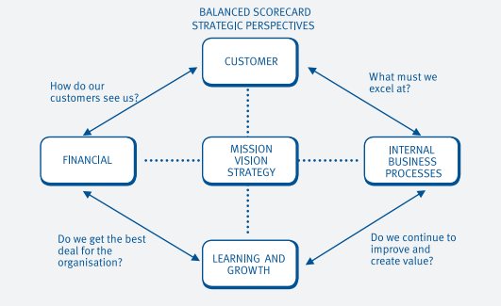

The financial perspective emphasizes on shareholder value satisfaction. The desirable performance measures here include ROCE, and return of shareholder’s funds. The customer perspective remains an attempt to measure the view of the firm in customer’s eye by customer satisfaction measurement. Appropriate performance measure is customer loyalty and customer satisfaction with the timeliness. The internal perspective purposes to measure the output of the firm based on technical excellence alongside needs of customer. Such indictors as unit cost and quality measurement are typical examples. Growth and learning perspective focuses on the continual improvement need for current products alongside techniques and new ones’ development to meet the changing needs of the client and customers (Brigham et al., 2016). The measure will comprise of revenue percentage attached to novel products.

Benchmarking
This technique has been growingly been embraced as mean for continuous enhancement. It is the establishment of comparators and targets via data collection that allow comparable performance levels (and specific underperformance areas) to be acknowledged. Performance should be improved by adopting identified best practices. There are different levels and types of benchmarking that are primarily described by whom firms selects to measure itself against. They are internal, competitive, functional, and strategic benchmarking. The functional benchmarking is where the frim compares itself with an identical function like order handling, selling or despatch in other firms that are never direct rivals. In competitive benchmarking, the firm uses the most successful rivals as its benchmark. The rivals are not likely to give willingly such crucial information to compare, however, it could be feasible for the firm to observe the performance of the competitor like observing how fast a specific rival process orders of customers.
In strategic benchmarking, it involves competitive form that is aiming at making decision for strategic step and change in the organization. Firms in one industry could agree to come together in a collaborative benchmarking procedure or process where the third party is selected to manage like a trade organization. This benchmarking type allows every firm in a scheme to submit its data regarding its respective performance the organizer of the scheme. The organizer subsequently computes the average performance values for the whole industry from the provided data. Every subject in this scheme is consequently provided with the average value of the industry that is used for assessing its individual performance.
In internal benchmarking, other departments or units within same firm are utilized as critical benchmarks. This could be feasible where the firm is big and subdivided into various identical regional segments. This type of benchmarking is broadly employed within the governments. For instance, in the United Kingdom, a Public Sector Benchmarking Services exist to maintain the performance measures’ database. Thus, public service firms including hospitals and fire stations are able to compare their individual performance against the best in the sector.
In systematic benchmarking process, planning, analysis, action and review are critical requirements. Planning entails the selection of the desired activities the firm needs to benchmark, full involvement of engaged staff with such an activity and the identification of critical phases of activity linking to outcomes, outputs and inputs. It is imperative that a benchmark be established to a specific “best practice” level. Analysis is comprised of the identification of the degree to which a firm underperforms and to trigger ideas as to how the firm can improve its performance. It might involve whether the novel methods or processes are needed. Implementation constitutes the utilization of the action plan to accomplish the maintenance or the improvement of the already determined standards. The management needs to make sure the availability of resources critical for meeting the set objectives. Action comprises placing a suitable plan into practice to enhance the performance in areas already benchmarked. The review calls for monitoring process or procedure vis-à-vis the plan and reviewing the performance measure’s appropriateness.
In reality, enterprises determining benchmark shall employ a range of sources of information for their schemes/programmes. The most desirable and valuable information might be that which arises from the partner in a benchmarking process. This partnership might be designed via trade associations as well as inter-organizational comparison networks. All firms can significantly benefit when they compare against each other. It must be ideally judged against the best practices wherever they are accessed. The analysis in benchmarking avails required comparisons of competences, and resources different activities and entire organizational competence.
Other performance measurement techniques also include value chain analysis, Product life cycle costing, throughput accounting and target costing. These, methods cut across both financial and non-financial metric of the organizations.

Value Chain Analysis
A value chain analysis is actually a process that entails the production, the designing, the making and the distribution of a products or service. It is the analysis of the business conduct of a company. The value chain is the organization of all the activities that have been involved form conceptualising a product or service to making it a reality and engaging a business process to make profit. This analysis takes two approaches, the differentiation approach and the cost advantage approach. The costs advantage approach identify the cost derivers of the primary and support activities in the value chain. The business then looks to reduce cost while maintaining value of the product or service knowing that it will have a ripple effect on the whole chain. The differentiation strategy on the other hand involves the prioritization of activities that bring the most value to the customers. The activities are evaluated to improve on the value.

Product life cycle cost analysis
This is a procedure that keeps track and accumulation of actual cost and income of a products since its inception to the end of its life. This tracking is done over several calendar years. He total cost entails the planning, acquisition design, support and other costs that are incurred directly from the product. This is tracked over the life of the product. In the light of full implication the LCC analysis helps in decision whether or not to keep a product, acquire the products form another company, refurbishment of the product or disposing off a non-performing product. It gives the longer term perceptive of the profitability of a product line and also enhances the control of manufacturing costs.
LCC analysis is characterised by market research that establishes the products desired by customers. His is followed by specification that gives details on the products such as expected performance or returns, required life and manufacturing costs. Designing follows next where drawing and process schedules and created. Prototype manufacture and development are then next stages when the product is made and changed until it meets specified requirements. Tooling follows as necessary tools are acquired for a production line. Then the commercial manufacture of the product commences as it undergoes selling, distribution and product support. The final stage of the life is decommissioning after which the plant utilised is sold or scrapped.

Throughput accounting
This is a process that makes a reflection on the realities of operation and is highly effective yet very simple to utilise. The approach of throughput accounting provides managers the information to make decisions that will increase profitability. It defines limiting factors against organizational goals and concentrates on the measures that drive behaviour towards reaching these goals. Unlike cost accounting however that mainly purposes to cut cost in bid to make profit, throughput accounting purposes to generate more outcome or throughput increasing he rate at which throughput is generated. It improves the performance of an organization by enforcing better management decision utilising the measurement s that reflect the effect of these decision though momentary variables including operating expenses, inventory or rather investments and throughput.

Target costing
Target costing is both an accounting and management technique that determines prices using the market conditions that are influenced by serval factors including competition level, switching costs, and homogenous products. While management has little or no control on selling price since it is market determined, the bets option is to control the cost. The formula used in target costing entails subtraction of the profit margin from the selling price of the product. The company includes in the target selling price, the minimum required profit. The total selling price also includes the customer specification, product design costs, as specification.

Conclusion
These methods are all equally important in measuring performance of a product and the general performance of the organization in comparison to competition and the current economic conditions. The best method however that can be recommended as ideal in reviewing both financial and non-financial metric in different conditions is that of value chain analysis. While the other methods Product life cycle costing, throughput accounting and target costing, are heavily skewed toward control of financial aspects of costs, the value chain approach utilises both cost advantage approach and differential a while giving options to utilize both or either of the approaches. It can effectively analyse finical metric on cist of the value chain and non-finical metrics on the value of the activities of the value chain.

Part 4: Key Issues Considered for Significant Expenditure Proposal

Introduction to capital Budgeting
There are various key issues considered when making a decision on a proposal for substantial expenditure. Various capital budgeting techniques are available for the use by the organizations. The techniques for capital budgeting are primarily categorized under two main techniques. These include discounting techniques as well as non-discounting techniques. In the former technique, various approaches can be used including the profitability index and payback period among others. In the same way, the Net Present Value (NPV), IRR, ROR, and modified IRR are the key discounting techniques available for the organizations to make investment decisions.

Payback Period
Based on this technique, the options for investment are chosen depending on the period of recovery of the original spending executed by the firm. The formula for this technique is as follows:
PP= A + (B divided by C). In this formula, A is equal to the corresponding year of the previous negative cumulative cash inflow where B denotes the absolute value of the previous negative cumulative cash inflow. C stands for the cash inflow of the consequent year of previous negative cumulative cash inflow. To illustrate this technique, we take the Unilever PLC organization with the following opportunity for investment with initial capital outlay of $10000000
1st year
2nd year
3rd year
4th year
5th year
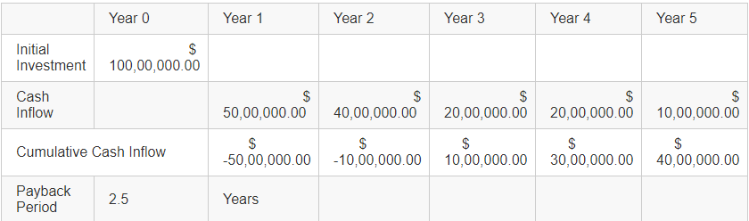

The Net Present Value
Where the payback period is employed broadly due to ease of access, the NPV, a discounting method, is further employed by the organization widely. The NPV’s formula is given as follows:
NPV equals C1/ (1+r) + C2/ (1+r) 2+ C3/ (1+r) 3+ C4/ (1+r) 4+C5/ (1+r) 5-C0; Where
C0 is initial investment
C1 is year 1 inflow
C2 is year 2 inflow
C3 is year 3 inflow
C4 is year 4 inflow
C5 is year 5 inflow
R is discount rate
Where the above opportunity for investment is under consideration, and where the required RR of Unilever is 12 percent, the NPV of the project is given as in the table below:
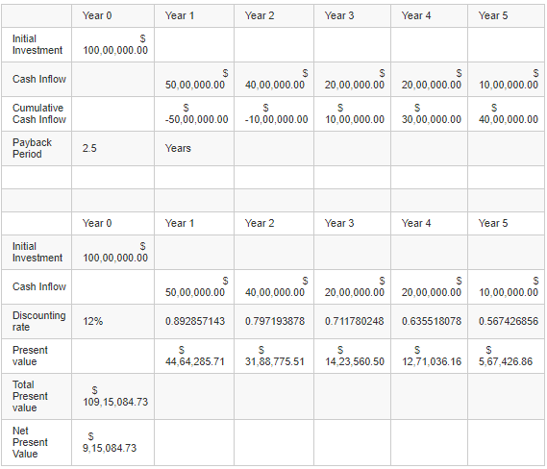

Internal Rate of return
It serves as a popular measure of the rate of return of an investment that utilises the only the internal rate and excludes eternal factors that may affect the reap from an investment. The calculations rely in the same formula as the NPV
IRR equals C1/ (1+r) + C2/ (1+r) 2+ C3/ (1+r) 3+ C4/ (1+r) 4+C5/ (1+r) 5-C0; Where
C0 is initial investment
C1 is year 1 inflow
C2 is year 2 inflow
C3 is year 3 inflow
C4 is year 4 inflow
C5 is year 5 inflow
However in comparison to the NPV and payback period, IRR is less effective in capturing the value of an investment as it counts out the external factors that play a major role in the performance of an investment.

Accounting rate of return
The accounting rate of return is a concept that considers the net income that can be brought froth form a an asset and divides it by the capital cost
ARR = Average Net Profit / Average capital cost

Conclusion
Based on the analysis of Unilever relative to its competitors, it is apparent that it profitability expanded between the two accounting periods (2015 and 2016 relative to its rivals (Henkel, Beiersdorf and Loreal). The company has an assignment to bring the money of information to the customers in the local sell to make it an addition of dissimilar locality and also nations. The Company has two business lines as pointed out above having 6 research centres in three continents and 71 centres for novelty across the world. Unilever has the propensity to market its product very forcefully .The company always follows the law and the directives pertaining to any market and has own marketing code of the conduct with a disagreeing point of view and cares for parental average towards the young children.

References
Abdallah, W. M., & Alnamri, M. (2015). Non-financial performance measures and the BSC of multinational companies with multi-cultural environment: An empirical investigation. Cross Cultural Management, 22(4), 594-607.
Gurufocus (2018). Unilever PLC.
Kaplan, R. (2016). Performance measurement techniques. R. Kaplan (Ed.), Management Accounting, 225-262.
Rubin, I. S. (2016). The politics of public budgeting: Getting and spending, borrowing and balancing. CQ Press.
Chisholm, D., Sweeny, K., Sheehan, P., Rasmussen, B., Smit, F., Cuijpers, P., & Saxena, S. (2016). Scaling-up treatment of depression and anxiety: a global return on investment analysis. The Lancet Psychiatry, 3(5), 415-424.
Brigham, E. F., Ehrhardt, M. C., Nason, R. R., & Gessaroli, J. (2016). Financial Managment: Theory And Practice, Canadian Edition. Nelson Education.
Macrotrends (2018). Unilever Financial Analysis.
MinnisRobinson, T. R., Henry, E., Pirie, W. L., Broihahn, M. A., & Cope, A. T. (2015). International Financial Statement Analysis, (CFA Institute Investment Series). John Wiley & Sons.

Appendix

Appedinx 1 Net Profit Margin Ratio
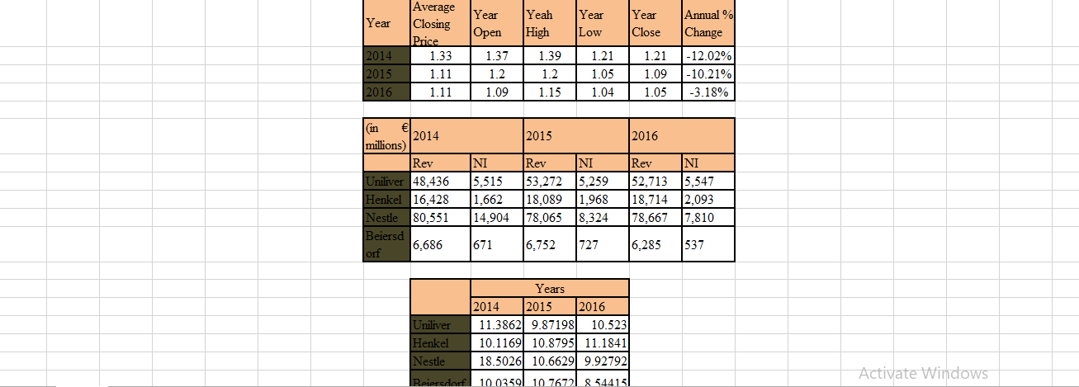

Appendix 2 Liquidity Ratio
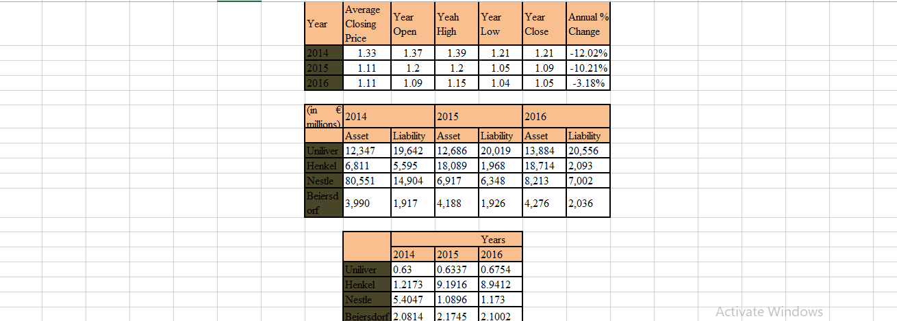

Appendix 3 Gross Profit Margin Ratio
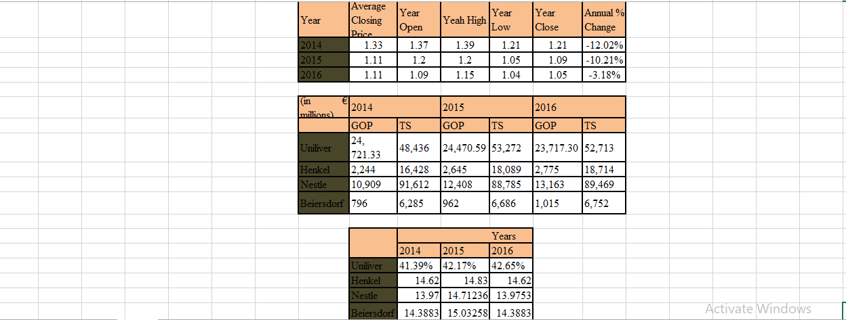

Appendix 4 Uniliver Financial Statement and Balance Sheet 2015-16

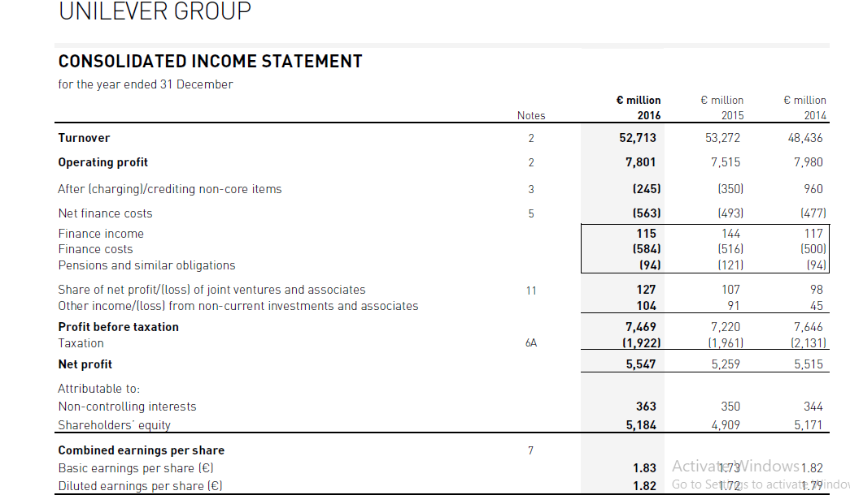
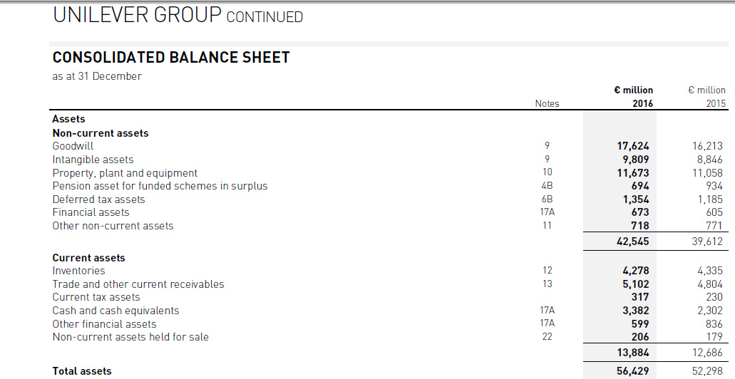
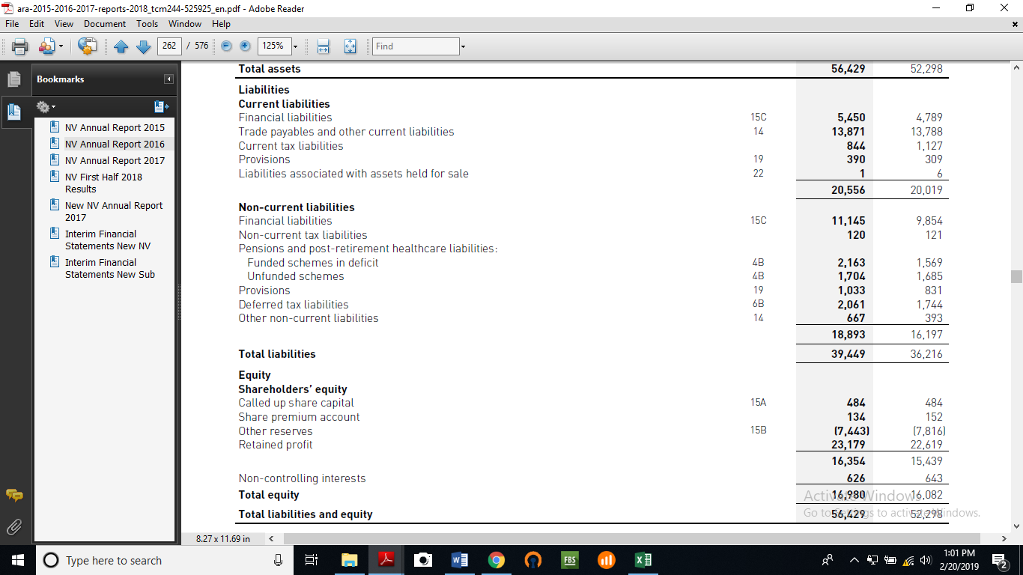

Appendix 5 Henkel Financial Statement and Balance Sheet 2015-16
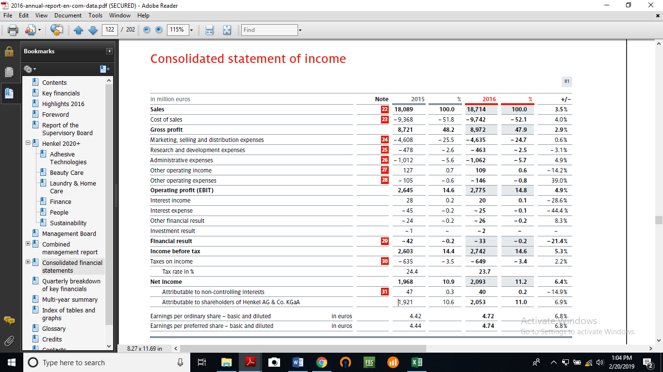
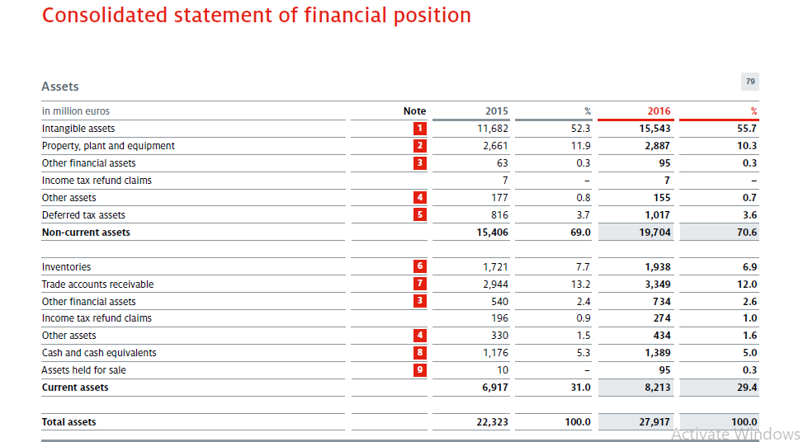
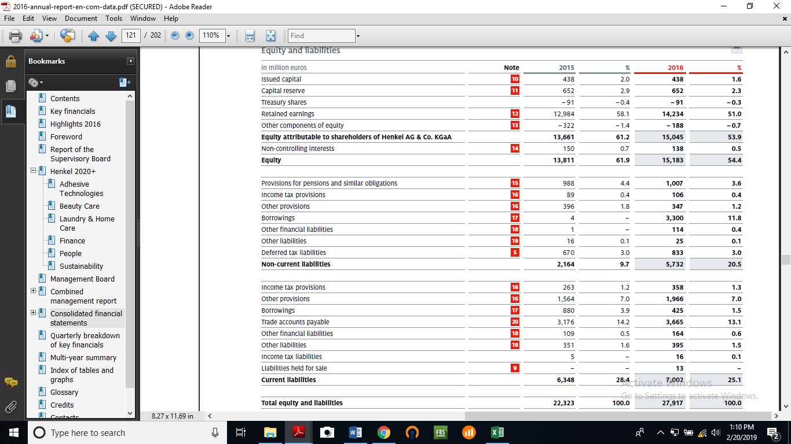

Appendix 6 Nestle Financial Statement and Balance Sheet 2015-16
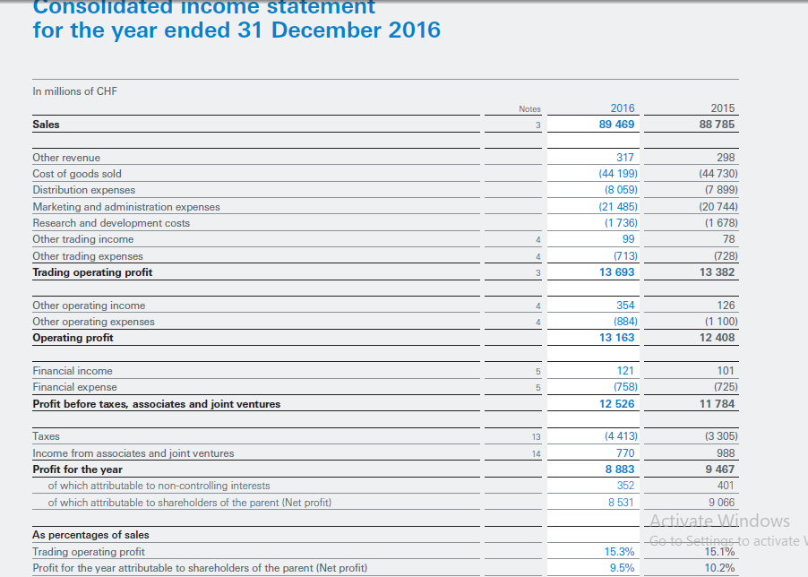

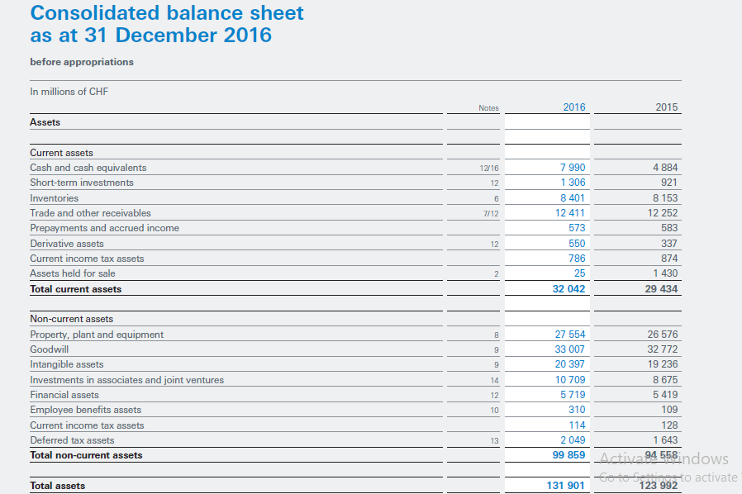

Appendix 7 Beiersdof Financial Statement and Balance Sheet 2015-16

